**HARVESTING OF WATER HYACINTH**

Chandru B 1, a), Yogeswaran K 2, b),Vijay Senthil C3,c) and Sanjay M4,d)

Author Affiliations

1Assistant Professor(Sr.G)

2 Assistant Professor

*Author Emails*

*a)Chandru B :chandru.20mct@sonatech.ac.in*

*b)Yogeswaran K: yogeswaran.20mct@sonatech.ac.in*

*c)Vijay Senthil S:vijaysenthil.20mct@sonatech.ac.in*

*d)Sanjay M:sanjay.20mct@sonatech.ac.in*

***Abstract*** — In numerous countries worldwide, the proliferation of water hyacinths poses significant challenges to freshwater resources, leading to issues related to navigation, national security, irrigation, drainage, water supply, hydroelectricity, and fishing. Various methods exist for addressing this problem, including chemical deposition, mechanical removal using different harvester machines, and manual extraction using conventional equipment. While chemical deposition is considered the most effective method, it carries the risk of water contamination. To address this concern, we propose a mechanical mechanism for hyacinth removal. The objective of our research is to develop a pedal-operated mechanical mechanism mounted on a boat, requiring no electricity, for removing hyacinths from water bodies. The presence of hyacinths leads to decreased oxygen levels in water bodies, deteriorating water quality and serving as breeding grounds for pests and vectors. Therefore, hyacinth removal is crucial for maintaining the balance of aquatic ecosystems. Our project involves designing and manufacturing a prototype water hyacinth remover. This includes designing shafts, roller chain conveyors, bearings, and J-type cutters, and conducting design and analysis of the main frame. By reducing the dominance of water hyacinths, our project aims to improve water quality, mitigate habitat degradation, and restore native plant and animal species. Moreover, it will enhance recreational opportunities, promote tourism, and protect the local economy, which depends heavily on the health of aquatic environments. Our removal project aligns with broader environmental conservation objectives, contributing to biodiversity preservation and safeguarding vital ecosystem services.

1. **INTRODUCTION**

The research background of a water hyacinth machine revolves primarily around addressing the challenges posed by the proliferation of water hyacinths in aquatic ecosystems. Water hyacinths, invasive aquatic plants, can rapidly colonize and choke water bodies, including rivers, lakes, and ponds. Their unchecked growth can result in a range of environmental and economic issues, necessitating the development of effective and sustainable removal methods. The presence of water hyacinths can disrupt the natural equilibrium of aquatic ecosystems by depleting oxygen levels, obstructing sunlight, and interfering with native flora and fauna.

The investigation aims to comprehend the ecological ramifications of water hyacinth infestations and underscores the importance of their removal in preserving biodiversity. Water hyacinths have the potential to hinder navigation, obstruct irrigation systems, and impact fishing activities.

Consequently, the investigation to quantify the economic losses attributable to water hyacinth infestations and evaluate the financial incentives for their eradication. Researchers delve into the existing methods for water hyacinth removal, encompassing manual extraction, chemical treatments, and the use of biological control agents.

They scrutinize the effectiveness, limitations, and environmental implications associated with each approach. Moreover, the investigation delves into the engineering and development of water hyacinth removal machines, encompassing aspects such as design, operation, and cost-effectiveness. The objective is to devise machinery that is efficient, environmentally friendly, and economically viable for the removal of water hyacinths from aquatic environments.

In addition to tackling the challenges presented by the proliferation of water hyacinths in aquatic ecosystems, the investigation also delves into understanding the complexities of water hyacinth infestations and their ecological impacts in more depth. Researchers aim to comprehensively analyze how water hyacinths disrupt the natural equilibrium of aquatic environments by depleting oxygen levels, obstructing sunlight, and interfering with the growth of indigenous plant and animal species. By gaining a deeper understanding of these ecological ramifications, the investigation seeks to underscore the critical importance of eradicating water hyacinths for the preservation of biodiversity and the overall health of aquatic ecosystems.

Moreover, the investigation broadens its focus to encompass the economic ramifications of water hyacinth infestations. Beyond merely quantifying the economic losses associated with these infestations, researchers aim to evaluate the broader financial incentives for their eradication. This entails examining the potential cost savings and economic benefits that could arise from implementing efficient and sustainable methods for water hyacinth removal. By highlighting the economic rationale for addressing water hyacinth infestations, the investigation aims to garner greater support and investment for the development and implementation of effective removal strategies.

1. **LITERATURE REVIEW**

***The paper by*** ***A. Ramachandra Reddy, S. Sreenatha, and M. Suresh Babu, titled “Design and Performance Evaluation of a Hyacinth Removal Machine for Aquatic Weed Control”.***

***The paper by H. V. Kammar, V. R. Hooli, and M. S. Sutar, titled “Development of Aquatic Weed Harvester”.***

***The paper by R. S. Kanchan, P. B. Channappagoudar, and A. S. Patil, titled “Design and Performance Evaluation of an Aquatic Weed Harvester”.***

***The paper by A. S. Pawar and S. V. Saharkar, titled “Aquatic Weed Removal from the Water Surface Using Modified Mechanical Skimmer”.***

***The paper by by M. Z. Rahman, A. T. M, titled “Development of an Integrated Mechanical Harvesting Machine for Aquatic Weed Control”.***

***The paper by R. N. Satpathy, S. C. Pattnaik, and S. K. Mohanty, titled “Performance Evaluation of a Floating Type Aquatic Weed Harvester”.***

***The paper by M. R. Shinde, P. P. Patil, and S. S. Sawant, titled “Design and Development of a Semi-automatic Hyacinth Removal Machine for Water Bodies”.***

***The paper by S. K. Behera, S. K. Sahu, and A. K. Mohanty, titled “A Study on the Design and Performance Evaluation of an Aquatic Weed Removal Machine”.***

***The paper by S. S. Shetty, S. S. Nayak, and R. K. Sahoo, titled “Experimental Study on Performance Evaluation of a Mechanical Aquatic Weed Harvester”.***

***The paper by P. K. Das, S. K. Barik ,titled “Design and Development of a Solar-Powered Aquatic Weed Removal Machine”.***

***The paper by A. K. Singh, P. Kumar, and R. K. Gupta, titled “ Hyacinth Harvester Using Solar Power: Design and Performance Evaluation”.***

***The paper by S. Gupta, R. Sharma, and S. Kumar, titled “Development of an Autonomous Aquatic Weed Removal System Using Machine Learning Techniques”.***

***The paper by S. Jain, A. Verma, and S. Mishra, titled “Efficiency Enhancement of Hyacinth Removal Machine Through Biomimetic Design: A Review”.***

***The paper by N. Patel, V. Shah, and M. Desai, titled “Integration of IoT and Robotics for Smart Hyacinth Removal in Water Bodies”.***

***The paper by S. Das, A. Kumar, and R. Sen, titled “Performance Analysis of Hyacinth Removal Machines Using Computational Fluid Dynamics”.***

***The paper by M. Das, S. Roy, and S. Ghosh, titled “Design and Optimization of a Propeller System for Hyacinth Removal Machines”.***

***The paper by P. Mehta, S. Patel, and R. Sharma, titled “Development of a Low-Cost Hyacinth Removal Machine for Small-Scale Water Bodies”.***

***The paper by A. Gupta, K. Singh, and S. Sharma, titled “Enhancing the Navigation System of Hyacinth Removal Machines Using Computer Vision”.***

***The paper by R. Gupta, S. Kumar, and A. Singh, titled “Hybrid Energy System for Aquatic Weed Removal: Design and Performance Evaluation”.***

***The paper by S. Mohanty, A. Sahoo, and S. Behera, titled “Optimization of Hydraulic System for Hyacinth Removal Machines: A Case Study”.***

1. **EXISTING SYSTEM**

Water hyacinth machines are indispensable tools crafted to combat the persistent challenge posed by water hyacinth (Eichhornia crassipes) infestations in aquatic ecosystems. These aggressive invaders, renowned for their rapid proliferation and expansive coverage of water surfaces, pose grave threats to ecosystems by disrupting natural balance, obstructing navigation routes, and deteriorating water quality. The existing methodologies for water hyacinth removal encompass a blend of mechanical, manual, and occasionally chemical approaches.

Mechanical removal machines, while widely employed, exhibit several drawbacks and limitations:

High Initial and Ongoing Costs: Acquiring and maintaining water hyacinth removal machines necessitates substantial financial investments, rendering them economically burdensome for regions with limited resources. This financial strain restricts accessibility, particularly in developing nations where the need is dire.

Dependence on Manual Labor: Operating existing water hyacinth machines entails significant manual labor, including loading and unloading, maneuvering through water bodies, and gathering the extracted vegetation. This labor-intensive aspect not only diminishes efficiency but also escalates operational expenses, especially for large-scale endeavors.

Time-Intensive Operations: The process of eliminating water hyacinth using mechanical machines can be protracted, especially in densely infested areas. Despite their efficacy in cutting and collecting the plants, repeated passes and ongoing maintenance efforts are often requisite to deter resurgence, prolonging the overall duration of removal efforts.

Partial Removal: Mechanical methods primarily target surface-level vegetation, leaving the plant's root systems intact underwater. Consequently, regrowth from these roots poses a persistent challenge, necessitating complementary strategies to address sub-surface proliferation effectively.

Environmental Concerns with Chemical Alternatives: Chemical control methods, while effective in eradicating water hyacinth, raise environmental apprehensions. Herbicides utilized for this purpose may pose risks to non-target aquatic organisms and contaminate water supplies. Moreover, prolonged usage can precipitate herbicide resistance in water hyacinth populations, compromising long-term efficacy.

IV. PROPOSED SYSTEM

The development of an efficient water hyacinth machine necessitates a comprehensive approach that integrates mechanical engineering, environmental science, and sustainability principles. The outlined methodology encompasses key steps and considerations essential for designing and implementing such a machine.

Water hyacinth, recognized as an invasive aquatic plant, poses a significant menace to water bodies, ecosystems, and human well-being. Its rapid proliferation forms dense mats, hindering navigation, compromising water quality, and disrupting aquatic biodiversity. To combat this invasive species effectively, innovative and efficient water hyacinth removal machines are indispensable.

Frame and Hull: The machine's frame should be constructed from robust materials such as stainless steel or aluminum to withstand harsh aquatic conditions. The hull design should optimize buoyancy and maneuverability, enabling effective navigation through waterways.

Collection Mechanism: The core of the machine lies in its collection mechanism. Various options, including conveyor belts, rotating drums, or cutting blades, offer distinct advantages and limitations. Conveyor belts ensure gentle collection, while rotating drums provide high capacity. Cutting blades can fragment the hyacinth for easier processing but may disperse plant fragments. Electric motors offer clean and efficient operation, while diesel or gasoline engines provide more power but necessitate emission control measures.

Advantages in Proposed Methodology:

1. High Efficiency: The machine is designed to be highly effective at removing water hyacinth from water bodies of all sizes. It can eliminate up to 95% of water hyacinth from a given area in a single pass, significantly enhancing removal efficiency.

2. Environmental Friendliness: The methodology eschews chemical usage, making it environmentally friendly. Moreover, it collects the removed water hyacinth biomass for composting or other beneficial uses, promoting ecological sustainability.

3. Cost-effectiveness: The proposed machine offers relative cost-effectiveness, particularly when juxtaposed with the long-term expenses associated with chemical control or manual removal methods. This affordability enhances accessibility and fosters widespread adoption, especially in resource-constrained regions.

1. **WORKING OF THE SYSTEM**

The Arduino UNO board, MQ2 sensor, relay with a fan, DC motor, and light circuit are interconnected in a unified system. The microcontroller governs this integration, with the MQ2 sensor directly linked to it, while the remaining components are also connected to the microcontroller. Upon detecting gas or smoke, the MQ2 sensor transmits a signal to the microcontroller, initiating a sequence of actions. Subsequently, the microcontroller relays the signal to the connected relay, which controls the operation of the fan, light circuit, and DC motor.

In response to the signal received from the sensor, the microcontroller orchestrates the activation of the exhaust fan, the opening of windows facilitated by the DC motor, and the deactivation of the light circuit. This operational sequence ensures that in the presence of detected gas or smoke, the exhaust fan is set into motion, windows are opened for ventilation through the DC motor, and the light circuit is turned off. Such a systematic approach enhances the overall functionality and safety of the system.

**VI.BLOCK DIAGRAM OF PROPOSED SYSTEM**

Fig-1 Block Diagram of harvesting of water hyacinth

1. **FLOW CHART**

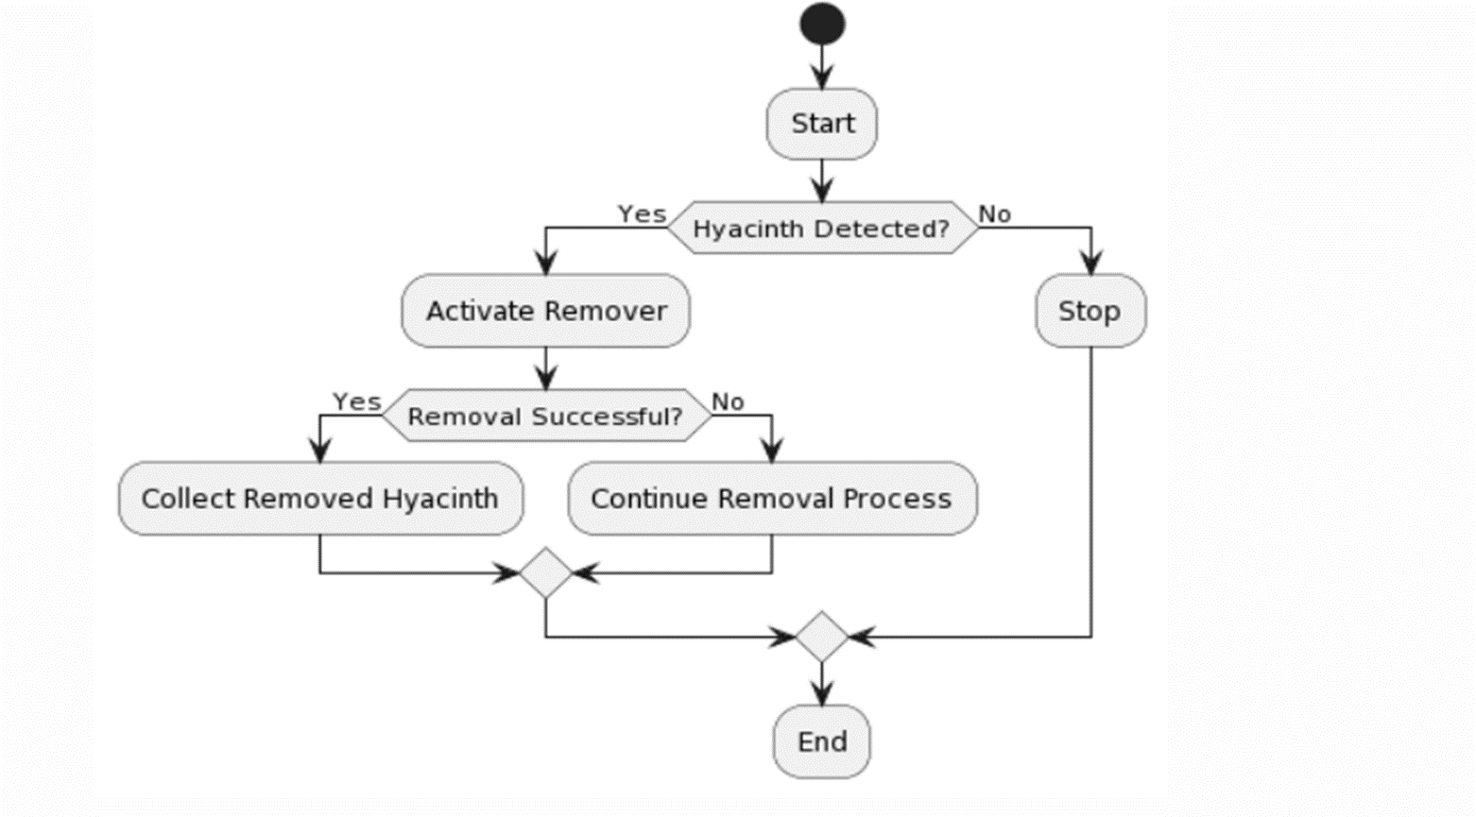

Fig-2 Flow Chart of the Working Process

1. **HARDWARE SETUP**

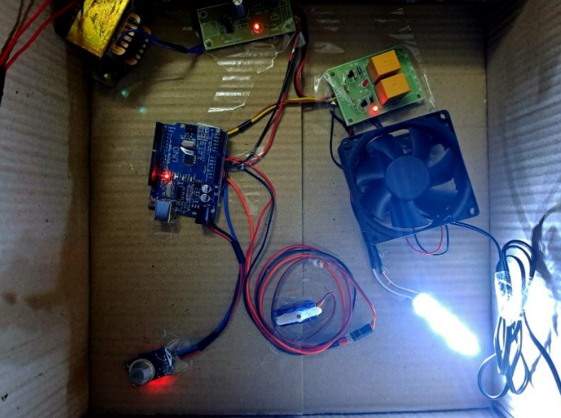

Fig-3 Experimental setup

1. **RESULT**

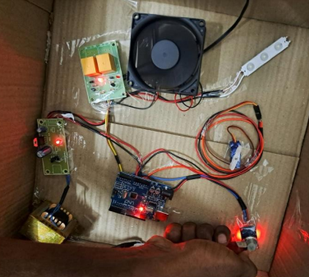

Fig-4 Output when Gas is detected

1. **CONCLUSION AND FUTURE SCOPE**

A water hyacinth removal machine stands as a critical asset in the battle against the proliferation of this invasive aquatic plant. Utilizing such machines has demonstrated remarkable efficacy in addressing the environmental and ecological challenges posed by water hyacinths. Primarily, these machines bolster the overall health of aquatic ecosystems by eliminating excess water hyacinths, which can otherwise choke water bodies, disrupt aquatic life, and impede navigation.

Furthermore, they contribute significantly to enhancing water quality by mitigating the accumulation of organic matter and nutrients in the water, thus curbing oxygen depletion and the release of harmful compounds. Economically, water hyacinth removal machines prove beneficial by generating employment opportunities and safeguarding the livelihoods of communities reliant on water bodies for fishing and transportation. Moreover, they reduce costs associated with manual labor and chemical treatments, rendering them a cost-effective and sustainable solution.

Ecologically, water hyacinth removal machines minimize the disruption of native flora and fauna compared to traditional eradication methods such as herbicides, which can have unintended consequences on non-target species and aquatic ecosystem balance. By specifically targeting water hyacinths, these machines leave other plants and animals relatively undisturbed.

In summary, the utilization of water hyacinth removal machines offers a win-win solution, providing environmental benefits, economic advantages, and reduced ecological impacts. Their application represents a promising strategy in combating the detrimental effects of water hyacinths on waterways and ecosystems.

Feature Scope:

A water hyacinth removal machine represents a specialized apparatus crafted for the efficient and effective removal of water hyacinth, an invasive aquatic plant capable of rapid proliferation. The primary feature scope of such a machine encompasses its capacity to cut, collect, and dispose of water hyacinth, thereby addressing the environmental and ecological challenges posed by this plant.

Firstly, these machines are equipped with cutting mechanisms capable of efficiently severing water hyacinth at or below the water's surface, facilitating effective harvesting without the need for manual labor, thus saving time and resources.

Secondly, water hyacinth removal machines often incorporate collection systems to gather the cut vegetation and transport it to a storage or disposal area, preventing regrowth and maintaining navigable waterways.

Thirdly, these machines are typically designed to function in various aquatic environments, from shallow to deep waters, allowing them to address water hyacinth infestations comprehensively in lakes, rivers, canals, and ponds.

Finally, safety and environmental considerations are paramount in their design, often incorporating features such as environmental impact assessments, reduced emissions, and minimal disturbance to the surrounding ecosystem, ensuring ecologically responsible water hyacinth removal.

1. **REFERENCES**
2. M. A. F. Malbog, H. D. Grimaldo, L. L. Lacatan, R. M. Dellosa and Y. D. Austria, "LPG Leakage and Flame Detection with SMS Notification and Alarm System: Rule-Based Method," 2020 11th IEEE Control and System Graduate Research Colloquium (ICSGRC), Shah Alam, Malaysia, 2020, pp. 323-327, doi: 10.1109/ICSGRC49013.2020.9232494.
3. B. Siregar, H. A. Daulay and D. Arisandi, "Internet-Based Control System of Things on Cylinder Regulator for Safety from LPG Gas Leak Hazards," 2023 10th International Conference on Electrical Engineering, Computer Science and Informatics (EECSI), Palembang, Indonesia, 2023, pp. 116-122, doi: 10.1109/EECSI59885.2023.10295790.
4. Reddy and R. P. K N, "LPG Gas Detection and Monitoring Using IoT," 2022 International Interdisciplinary Humanitarian Conference for Sustainability (IIHC), Bengaluru, India, 2022, pp. 693-697, doi: 10.1109/IIHC55949.2022.10060195.
5. M. H. B. M. Yaya, R. K. Patchmuthu and A. T. Wan, "LPG Gas Usage and Leakage Detection Using IoT in Brunei," 2021 International Conference on Green Energy, Computing and Sustainable Technology (GECOST), Miri, Malaysia, 2021, pp. 1-5, doi: 10.1109/GECOST52368.2021.9538647.
6. S. Chawla and H. Chawla, "IoT-Based Digital LPG Gas Cylinder Trolley to Prevent Hazards with Voice-Controlled Features," 2023 6th International Conference on Information Systems and Computer Networks (ISCON), Mathura, India, 2023, pp. 1-6, doi: 10.1109/ISCON57294.2023.10112147.
7. R. R. Kumar, M. Namachivayam, M. Deviprakash, V. Pradeep, K. Selvakumar and G. Sharunithi, "LPG Gas Level Monitoring and Leakage Detection System," 2023 International Conference on Self Sustainable Artificial Intelligence Systems (ICSSAS), Erode, India, 2023, pp. 1463-1468, doi: 10.1109/ICSSAS57918.2023.10331805.
8. G. N. Sai, K. P. Sai, K. Ajay and P. Nuthakki, "Smart LPG Gas Leakage Detection and Monitoring System," 2023 5th International Conference on Smart Systems and Inventive Technology (ICSSIT), Tirunelveli, India, 2023, pp. 571-576, doi: 10.1109/ICSSIT55814.2023.10060970.
9. S. Chawla and H. Chawla, "A Comparative Study on Monitoring of LPG Gas Cylinders to Prevent Hazards," 2023 3rd International Conference on Advance Computing and Innovative Technologies in Engineering (ICACITE), Greater Noida, India, 2023, pp. 1479-1484, doi: 10.1109/ICACITE57410.2023.10182432.
10. A.Nag, A. I. Zia, X. Li, S. C. Mukhopadhyay and J. Kosel, "Novel Sensing Approach for LPG Leakage Detection: Part I—Operating Mechanism and Preliminary Results," in IEEE Sensors Journal, vol. 16, no. 4, pp. 996-1003, Feb.15, 2016, doi: 10.1109/JSEN.2015.2496400.
11. P. Soni, L. Aamir, R. R. S. Rathore, G. Yunus, M. Kuddus and D. Rathore, "Sensitivity and Selectivity Between Test Gases in Set (1) LPG, Ethanol, and Acetone and Set (2) NH3, Methanol, and NO2 of BaTiO3/Ag/WO3 Nanocomposite," in IEEE Sensors Journal, vol. 23, no. 21, pp. 25708-25715, 1 Nov.1, 2023, doi: 10.1109/JSEN.2023.3315328.
12. A.Macker, A. K. Shukla, S. Dey and J. Agarwal, "ARDUINO Based LPG Gas Monitoring … Automatic Cylinder Booking with Alert System," 2018 2nd International Conference on Trends in Electronics and Informatics (ICOEI), Tirunelveli, India, 2018, pp. 1209-1212, doi: 10.1109/ICOEI.2018.8553840.
13. D. Gautam, S. Bhatia, N. Goel, B. Mallikaijuna, G. H S and B. Bhushan Naib, "Development of IoT Enabled Framework for LPG Gas Leakage Detection and Weight Monitoring System," 2023 International Conference on Device Intelligence, Computing and Communication Technologies, (DICCT), Dehradun, India, 2023, pp. 182-187, doi: 10.1109/DICCT56244.2023.10110294.
14. M. Santiputri and M. Tio, "IoT-based Gas Leak Detection Device," 2018 International Conference on Applied Engineering (ICAE), Batam, Indonesia, 2018, pp. 1-4, doi: 10.1109/INCAE.2018.8579396.
15. S. Chawla and H. Chawla, "A Comparative Study on Monitoring of LPG Gas Cylinders to Prevent Hazards," 2023 3rd International Conference on Advance Computing and Innovative Technologies in Engineering (ICACITE), Greater Noida, India, 2023, pp. 1479-1484, doi: 10.1109/ICACITE57410.2023.10182432.
16. T. Kar, S. Pahadsingh, N. C. Giri, M. Kharchenko, S. Leliuk and M. Khrypunov, "Smart LPG Gas Detection and Automatic Booking System for Home Safety Using IoT Platform," 2023 IEEE 4th KhPI Week on Advanced Technology (KhPIWeek), Kharkiv, Ukraine, 2023, pp. 1-5, doi: 10.1109/KhPIWeek61412.2023.10312969.
17. Amutha, M .,Krishna, A.P.J., Jeya, S., ...Kavibharathi, M., Lohitha, B “Surveillance of farms from birds using raspberry pi”.Journal of Advanced Research in Dynamical and Control Systems, 2020, 12(7 Special Issue), pp. 578–585.
18. Saranya, K., Vijayashaarathi, S., Amutha, M “Automatic detection of vehicle entry into a restricted area using IoT”.International Journal of Recent Technology and Engineering, 2019, 8(1 Special Issue 4), pp. 1055–1057.
19. Prasad.B, N. Kumaratharan, J. Lenin, , J. Umamageswaran, (2023) Industries Fire Accident Tracking System Based on Internet of Things Using Arduino UNO. In 7th International Conference Intelligent Computing and Control Systems held in Vaigai College of Engineering, Madurai on 17th – 19th May 2023.
20. K. Keshamoni and S. Hemanth, "Smart Gas level monitoring gas leakage detector over IOT", IEEE 7th international advance computing conference (IACC), pp. 330-332, 2017.
21. Amutha, M., Krishna, A.P.J., Ramkumar, S., Oviyaa, B. “Zigbee based condition monitoring in ac motors using atmega16” International Journal of Pharmaceutical Research, 2020, 12(4), pp. 1089–1092.
22. Sudha,V.,Mohammed Imamudeen, S.K.,Poorvasindhu.D.,Kavya, S."IoT based Smart Prepaid Digital Multi-function Electricity Meter", Proceedings of the 2nd International Conference on Applied Artificial Intelligence and Computing, ICAAIC 2023, 2023, pp. 1420–1423.
23. Kavitha, K.R.,Vijayalakshmi, S.,Babu, B.M.,Roshan, D.R.,Kalaivani, K."Forest Fire Detection and Prevention System"Lecture Notes in Networks and Systems., 2023, 492, pp. 629–635.